**Classical Reports**

Example 1: Display Sales Order Header Details with the given Order Number

Program:

| REPORT zcr_sales_header_details_01.  PARAMETERS p_vbeln TYPE vbak-vbeln.  TYPES: BEGIN OF ty_sales_order,  vbeln TYPE vbak-vbeln,  auart TYPE vbak-auart,  kunnr TYPE vbak-kunnr,  audat TYPE vbak-audat,  netwr TYPE vbak-netwr,  waerk TYPE vbak-waerk,  END OF ty_sales_order.  DATA ls_sales_order TYPE ty_sales_order.  START-OF-SELECTION.  SELECT SINGLE vbeln,  auart,  kunnr,  audat,  netwr,  waerk  FROM vbak  WHERE vbeln = @p_vbeln  INTO @ls_sales_order.   WRITE: TEXT-001, "Order Number  TEXT-002, "Order Type  TEXT-003, "Sold-To Party  TEXT-004, "Document Date  TEXT-005, "Net Value  TEXT-006. "Currency   WRITE: / ls_sales_order-vbeln,  ls_sales_order-auart,  ls_sales_order-kunnr,  ls_sales_order-audat,  ls_sales_order-netwr,  ls_sales_order-waerk. |
| --- |

Output:

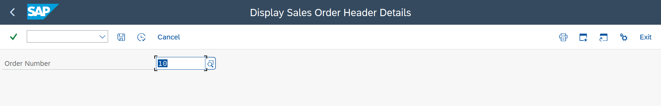

On Execute

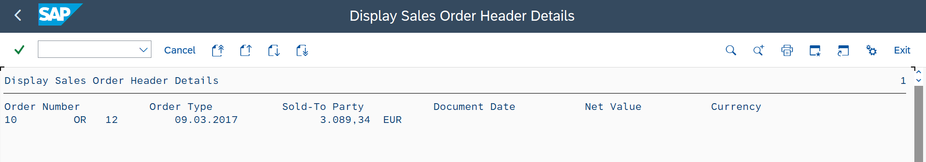

Here Column Header and Data are not aligned properly.

Example 2: Display Sales Order Header Details with the given Order Number and the Column header should be appropriately aligned with the data

Output:

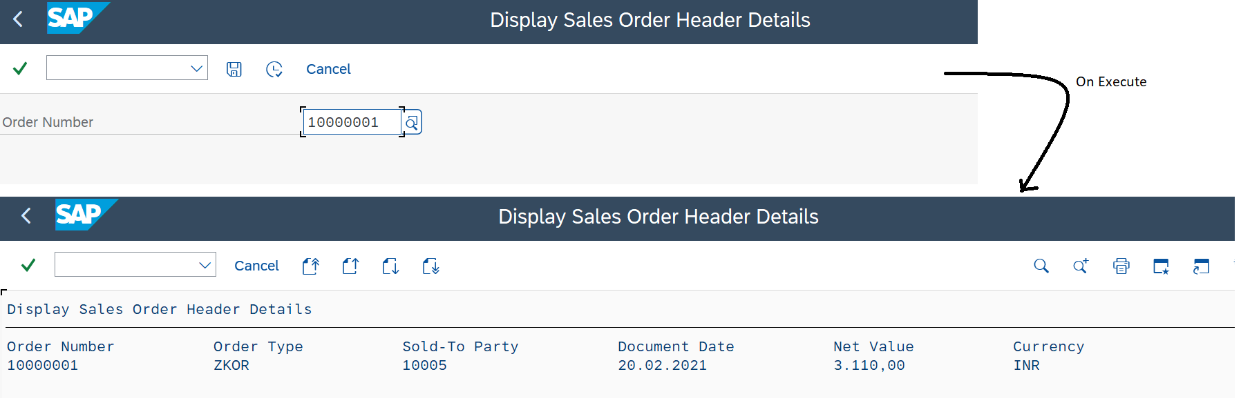

**1st Version:**

Program: The remaining code is the same as Example 1

| WRITE: / ls_sales_order-vbeln UNDER text-001,  ls_sales_order-auart UNDER text-002,  ls_sales_order-kunnr UNDER text-003,  ls_sales_order-audat UNDER text-004,  ls_sales_order-netwr UNDER text-005,  ls_sales_order-waerk UNDER text-006. |
| --- |

**2nd Version:**

Program:

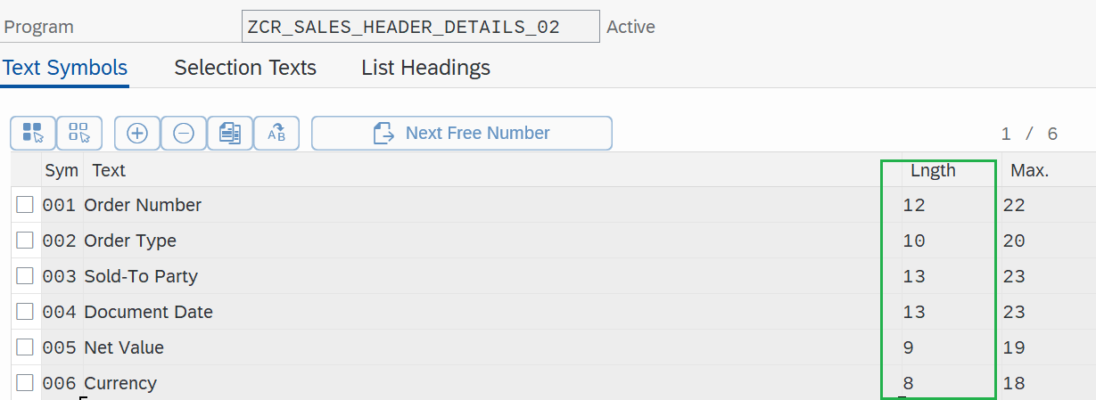

Here we are giving space value based on the length of Text Symbols Text + 2(Extra Space)

| WRITE: TEXT-001, "Order Number  14 TEXT-002, "Order Type (12+2)   26 TEXT-003, "Sold-To Party (14+10+2)  41 TEXT-004, "Document Date (26+13+2)  56 TEXT-005, "Net Value  67 TEXT-006. "Currency   WRITE: / ls_sales_order-vbeln UNDER text-001,  ls_sales_order-auart UNDER text-002,  ls_sales_order-kunnr UNDER text-003,  ls_sales_order-audat UNDER text-004,  ls_sales_order-netwr UNDER text-005 LEFT-JUSTIFIED,  ls_sales_order-waerk UNDER text-006. |
| --- |

Output 2: We can also give custom space between column headers by directly specifying the value

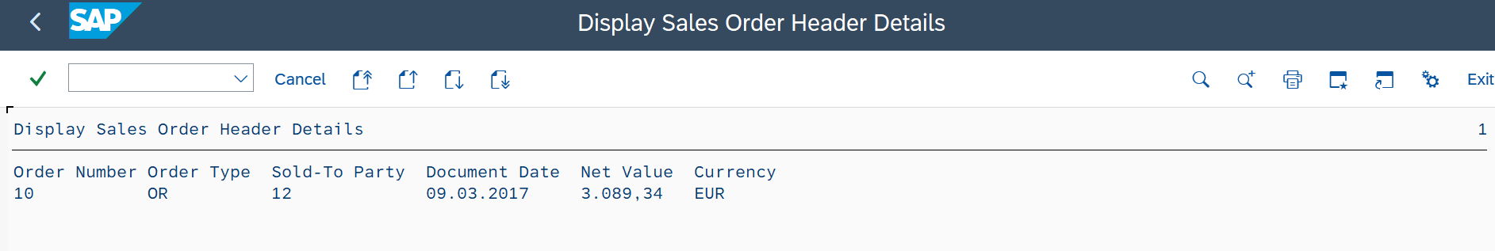

Example 3: Based on a Given Order number(Parameter) display Sales Order Items Details

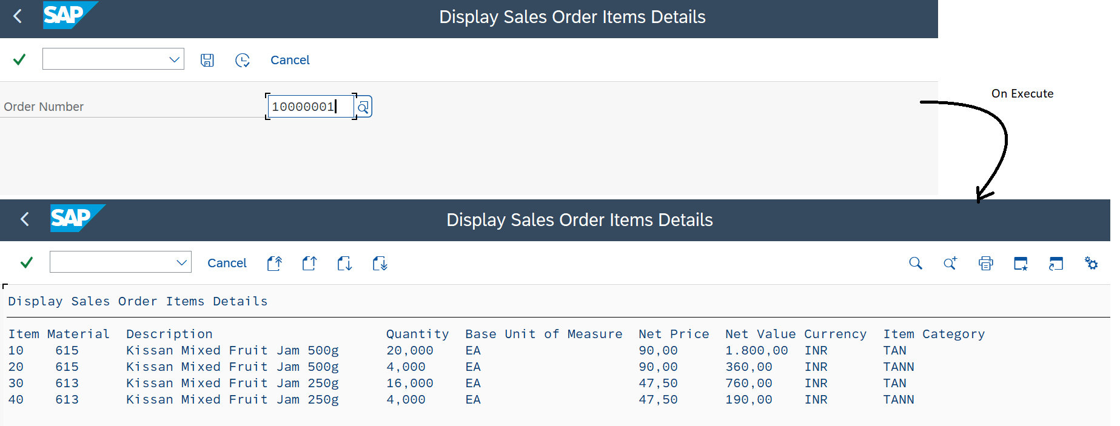

Program:

| REPORT zcr_sales_order_items_details.  PARAMETERS p_vbeln TYPE vbak-vbeln.  START-OF-SELECTION.  SELECT posnr,  matnr,  arktx,  kwmeng,  meins,  netpr,  netwr,  waerk,  pstyv  FROM vbap  WHERE vbeln = @p_vbeln  INTO TABLE @DATA(lt_sales_order_items).   WRITE: TEXT-001,"Item  6 TEXT-002,"Material  16 TEXT-003,"Description *Adding an extra 30 spaces because it contains a description value length is 40char  49 TEXT-004,"Quantity  59 TEXT-005, "Base Unit of Measure  81 TEXT-006, "Net Price  92 TEXT-007, "Net Value  102 TEXT-008,"Currency  112 TEXT-009."Item Category   LOOP AT lt_sales_order_items ASSIGNING FIELD-SYMBOL(<lwa_sales_order_items>).   WRITE: / |{ <lwa_sales_order_items>-posnr ALPHA = OUT }| UNDER TEXT-001, "Removing Zeros from ItemNumber befor display  | { <lwa_sales_order_items>-matnr ALPHA = OUT } | UNDER TEXT-002,  <lwa_sales_order_items>-arktx UNDER TEXT-003,  <lwa_sales_order_items>-kwmeng UNDER TEXT-004 LEFT-JUSTIFIED,  <lwa_sales_order_items>-meins UNDER TEXT-005,  <lwa_sales_order_items>-netpr UNDER TEXT-006 LEFT-JUSTIFIED,  <lwa_sales_order_items>-netwr UNDER TEXT-007 LEFT-JUSTIFIED,  <lwa_sales_order_items>-waerk UNDER TEXT-008,  <lwa_sales_order_items>-pstyv UNDER TEXT-009.  ENDLOOP. |
| --- |

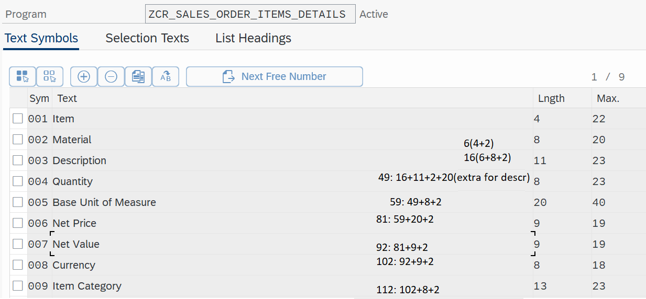

Example 4: Based on a Given Order number(Select options) display Sales Order Items Details

Output:

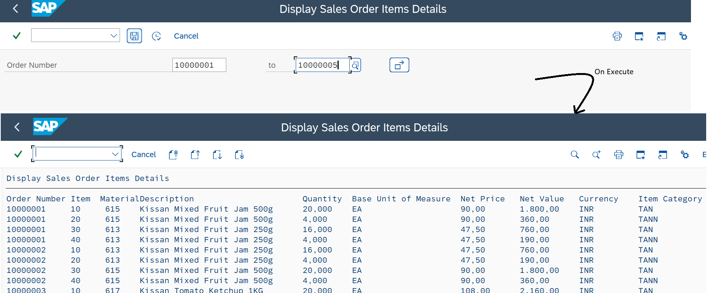

Program:

| REPORT zcr_sales_order_items_details2.  DATA lv_vbeln TYPE vbak-vbeln.  SELECT-OPTIONS so_vbeln FOR lv_vbeln.  START-OF-SELECTION.  SELECT vbeln,  posnr,  matnr,  arktx,  kwmeng,  meins,  netpr,  netwr,  waerk,  pstyv  FROM vbap  WHERE vbeln IN @so_vbeln  INTO TABLE @DATA(lt_sales_order_items).   WRITE: TEXT-000,  14 TEXT-001,"Item  20 TEXT-002,"Material  28 TEXT-003,"Description *Adding an extra 30 spaces because it contains a description value of up to 40char  61 TEXT-004,"Quantity  71 TEXT-005, "Base Unit of Measure  93 TEXT-006, "Net Price  105 TEXT-007, "Net Value  117 TEXT-008,"Currency  129 TEXT-009."Item Category   LOOP AT lt_sales_order_items ASSIGNING FIELD-SYMBOL(<lwa_sales_order_items>).   WRITE: / <lwa_sales_order_items>-vbeln UNDER TEXT-000,  |{ <lwa_sales_order_items>-posnr ALPHA = OUT }| UNDER TEXT-001, "Removing Zeros from ItemNumber before display  | { <lwa_sales_order_items>-matnr ALPHA = OUT } | UNDER TEXT-002,  <lwa_sales_order_items>-arktx UNDER TEXT-003,  <lwa_sales_order_items>-kwmeng UNDER TEXT-004 LEFT-JUSTIFIED,  <lwa_sales_order_items>-meins UNDER TEXT-005,  <lwa_sales_order_items>-netpr UNDER TEXT-006 LEFT-JUSTIFIED,  <lwa_sales_order_items>-netwr UNDER TEXT-007 LEFT-JUSTIFIED,  <lwa_sales_order_items>-waerk UNDER TEXT-008,  <lwa_sales_order_items>-pstyv UNDER TEXT-009.  ENDLOOP. |
| --- |

Example 5: Based on a Given Order number(Select options) display the Sales Order header and Items Details

Output:

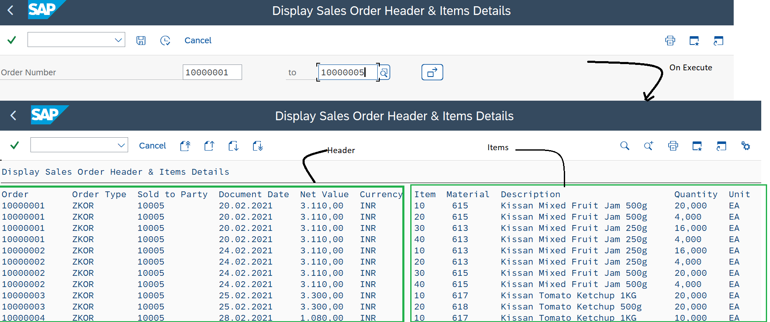

Program:

| REPORT zcr_sales_order_items_details3.  DATA lv_vbeln TYPE vbak-vbeln.  SELECT-OPTIONS so_vbeln FOR lv_vbeln.  START-OF-SELECTION.  SELECT a~vbeln,  a~auart,  a~kunnr,  a~audat,  a~netwr,  a~waerk,  b~posnr,  b~matnr,  b~arktx,  b~kwmeng,  b~meins  FROM vbak AS a  INNER JOIN vbap AS b  ON a~vbeln = b~vbeln  WHERE a~vbeln IN @so_vbeln  INTO TABLE @DATA(lt_sales_order).   WRITE: TEXT-000,"Order  14 TEXT-001, "Order Type  26 TEXT-002, "Sold to Party  41 TEXT-003, "Document Date  56 TEXT-004, "Net Value  67 TEXT-005, "Currency  77 TEXT-006, "Item  83 TEXT-007, "Material  93 TEXT-008, "Description  125 TEXT-009,"Quantity  135 TEXT-010. "Unit   LOOP AT lt_sales_order ASSIGNING FIELD-SYMBOL(<lwa_sales_order>).   WRITE: / <lwa_sales_order>-vbeln UNDER TEXT-000,  <lwa_sales_order>-auart UNDER TEXT-001,  <lwa_sales_order>-kunnr UNDER TEXT-002,  <lwa_sales_order>-audat UNDER TEXT-003,  <lwa_sales_order>-netwr UNDER TEXT-004 LEFT-JUSTIFIED,  <lwa_sales_order>-waerk UNDER TEXT-005,  |{ <lwa_sales_order>-posnr ALPHA = OUT }| UNDER TEXT-006, "Removing Zeros from ItemNumber before display  | { <lwa_sales_order>-matnr ALPHA = OUT } | UNDER TEXT-007,  <lwa_sales_order>-arktx UNDER TEXT-008,  <lwa_sales_order>-kwmeng UNDER TEXT-009 LEFT-JUSTIFIED,  <lwa_sales_order>-meins UNDER TEXT-010.   ENDLOOP. |
| --- |

Example 6: Display Item Details in Table Format using WRITE, SY-VLINE and SY_ULINE System variables

Output:

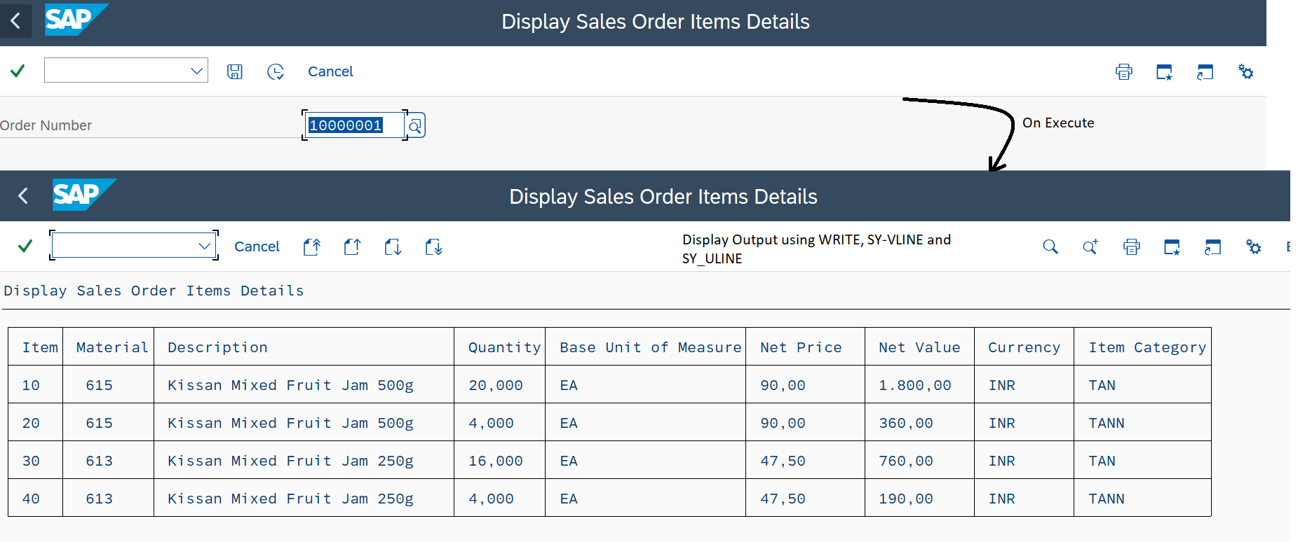

Program:

| REPORT zcr_sales_order_items_details4.  PARAMETERS: p_vbeln TYPE vbak-vbeln.  START-OF-SELECTION.  SELECT posnr,  matnr,  arktx,  kwmeng,  meins,  netpr,  netwr,  waerk,  pstyv  FROM vbap  WHERE vbeln = @p_vbeln  INTO TABLE @DATA(lt_sales_order_items).   WRITE sy-uline(133).  NEW-LINE.   WRITE: sy-vline, TEXT-001, "Item  7 sy-vline, TEXT-002,"Material  17 sy-vline,TEXT-003,"Description  50 sy-vline,TEXT-004,"Quantity  60 sy-vline, TEXT-005, "Base Unit of Measure  82 sy-vline,TEXT-006,"Net Price  95 sy-vline,TEXT-007,"Net Value  107 sy-vline,TEXT-008,"Currency  118 sy-vline,TEXT-009,"Item Category  133 sy-vline.   WRITE sy-uline(133).   LOOP AT lt_sales_order_items ASSIGNING FIELD-SYMBOL(<lwa_sales_order_items>).   WRITE: / sy-vline,|{ <lwa_sales_order_items>-posnr ALPHA = OUT }| UNDER TEXT-001, "Removing Zeros from ItemNumber befor display  7 sy-vline,| { <lwa_sales_order_items>-matnr ALPHA = OUT } | UNDER TEXT-002,  17 sy-vline,<lwa_sales_order_items>-arktx UNDER TEXT-003,  50 sy-vline,<lwa_sales_order_items>-kwmeng UNDER TEXT-004 LEFT-JUSTIFIED,  60 sy-vline,<lwa_sales_order_items>-meins UNDER TEXT-005,  82 sy-vline,<lwa_sales_order_items>-netpr UNDER TEXT-006 LEFT-JUSTIFIED,  95 sy-vline,<lwa_sales_order_items>-netwr UNDER TEXT-007 LEFT-JUSTIFIED,  107 sy-vline,<lwa_sales_order_items>-waerk UNDER TEXT-008,  118 sy-vline,<lwa_sales_order_items>-pstyv UNDER TEXT-009,  133 sy-vline.   WRITE sy-uline(133).  ENDLOOP. |
| --- |

Example 7: Classical Report Events

Output:

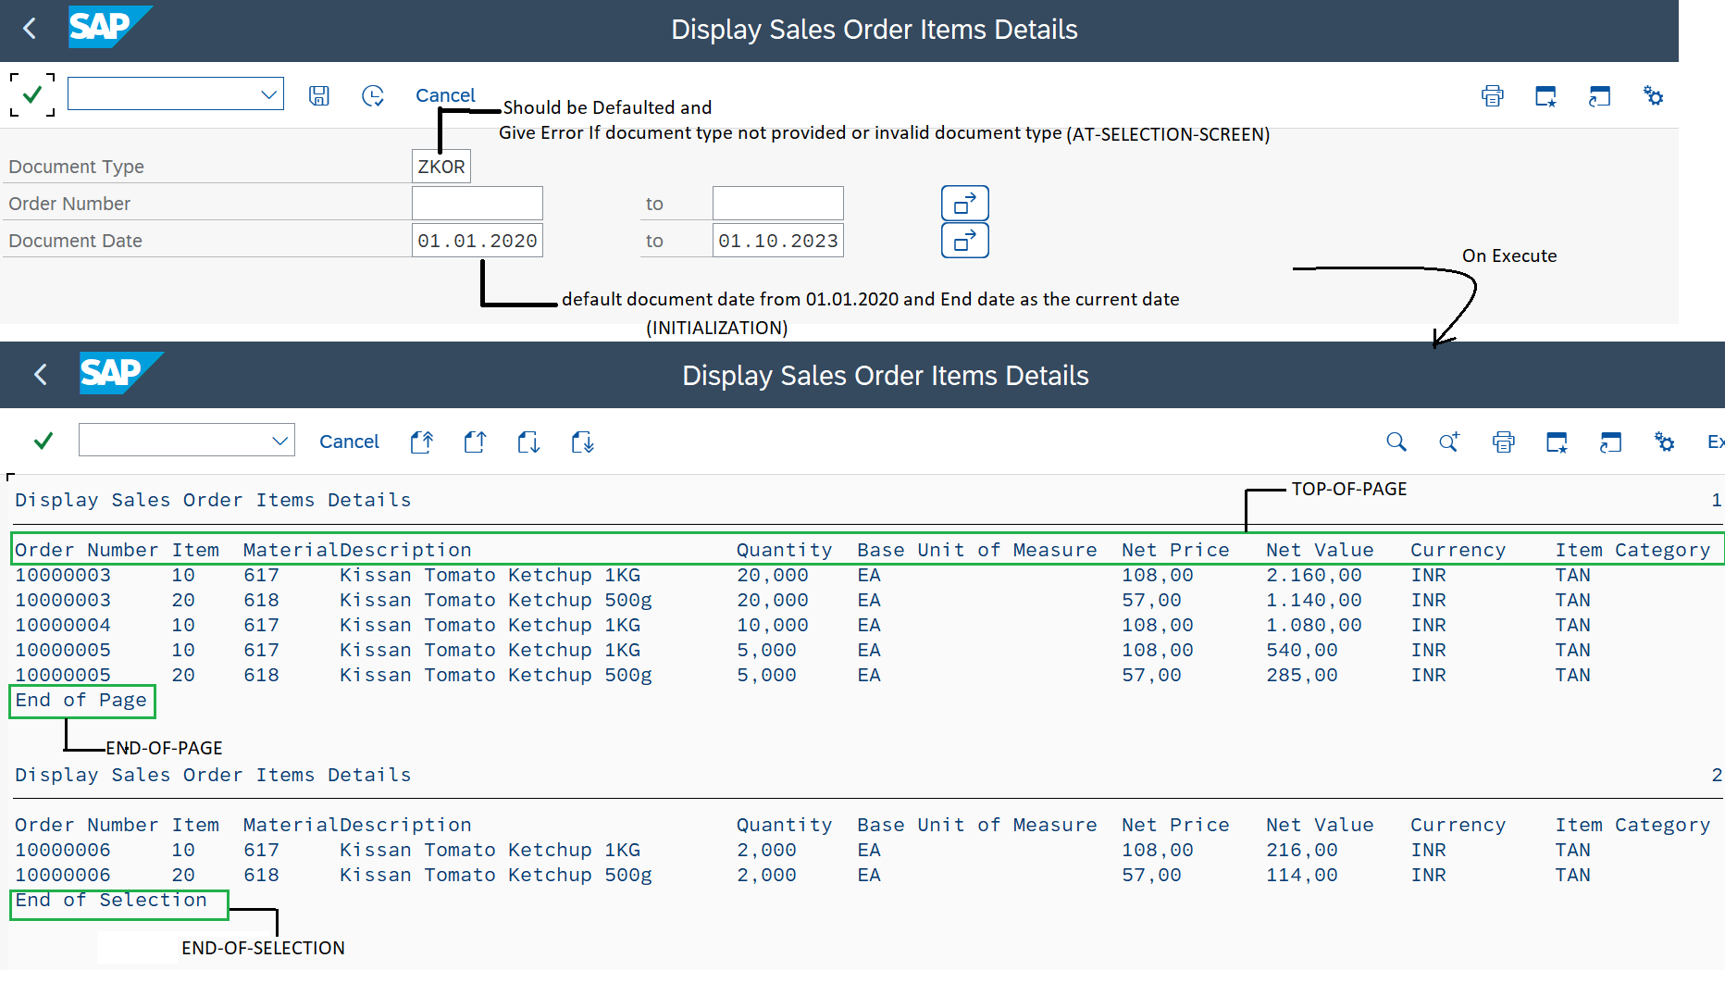

Program:

| REPORT zcr_events LINE-COUNT 10(2).  DATA: lv_vbeln TYPE vbak-vbeln,  lv_audat TYPE vbak-audat.  PARAMETERS p_auart TYPE vbak-auart DEFAULT 'ZKOR'."Document Type  SELECT-OPTIONS: so_vbeln FOR lv_vbeln,"Order Number  so_audat FOR lv_audat."Document Date  INITIALIZATION. ****When we have to propose a calculated default value then we use initialization event ****otherwise provide value at the time of declaration  so_audat-sign = 'I'.  so_audat-option = 'BT'.  so_audat-low = '20200101'. "YYYYMMDD  so_audat-high = sy-datum.  APPEND so_audat.  AT SELECTION-SCREEN."It gets triggered on every action and it is used to validate the input  IF p_auart IS INITIAL. ****Select document type  MESSAGE e000(zmsg_01).  ELSE.  SELECT SINGLE auart  FROM tvak  WHERE auart EQ @p_auart  INTO @DATA(lv_auart).   IF lv_auart IS INITIAL. ****Document Type &1 is invalid; enter valid document type  MESSAGE e001(zmsg_01) WITH p_auart.  ENDIF.  ENDIF.  *AT SELECTION-SCREEN OUTPUT. *AT SELECTION-SCREEN ON VALUE-REQUEST FOR {field}. *AT SELECTION-SCREEN ON HELP-REQUEST FOR {}. *AT SELECTION-SCREEN ON {Field}.  TOP-OF-PAGE.  WRITE: TEXT-000,  14 TEXT-001, "Item  20 TEXT-002, "Material  28 TEXT-003, "Description  61 TEXT-004, "Quantity  71 TEXT-005, "Base Unit of Measure  93 TEXT-006, "Net Price  105 TEXT-007, "Net Value  117 TEXT-008, "Currency  129 TEXT-009. "Item Category  END-OF-PAGE.  WRITE TEXT-010."End of Page  START-OF-SELECTION."Gets Trigger when we click on Execute  SELECT vbeln  FROM vbak  WHERE vbeln IN @so_vbeln  AND audat IN @so_audat  AND auart EQ @p_auart  INTO TABLE @DATA(lt_sales_order).   IF NOT lt_sales_order IS INITIAL.  SELECT vbeln,  posnr,  matnr,  arktx,  kwmeng,  meins,  netpr,  netwr,  waerk,  pstyv  FROM vbap  FOR ALL ENTRIES IN @lt_sales_order  WHERE vbeln EQ @lt_sales_order-vbeln  INTO TABLE @DATA(lt_sales_order_items).   CHECK NOT lt_sales_order_items IS INITIAL.  ENDIF.   LOOP AT lt_sales_order_items ASSIGNING FIELD-SYMBOL(<lwa_sales_order_items>).   WRITE: / <lwa_sales_order_items>-vbeln UNDER TEXT-000,  |{ <lwa_sales_order_items>-posnr ALPHA = OUT }| UNDER TEXT-001,  |{ <lwa_sales_order_items>-matnr ALPHA = OUT }| UNDER TEXT-002,  <lwa_sales_order_items>-arktx UNDER TEXT-003,  <lwa_sales_order_items>-kwmeng UNDER TEXT-004 LEFT-JUSTIFIED,  <lwa_sales_order_items>-meins UNDER TEXT-005,  <lwa_sales_order_items>-netpr UNDER TEXT-006 LEFT-JUSTIFIED,  <lwa_sales_order_items>-netwr UNDER TEXT-007 LEFT-JUSTIFIED,  <lwa_sales_order_items>-waerk UNDER TEXT-008,  <lwa_sales_order_items>-pstyv UNDER TEXT-009.  ENDLOOP.  END-OF-SELECTION.  WRITE TEXT-011."End of Selection |
| --- |